**Docker Pipeline**

**Prerequisite :**

1. Need to create one Self-hosted agent which have docker installed.
2. One “Docker Registry” Service Connection need to create for docker hub where our image can pull or push

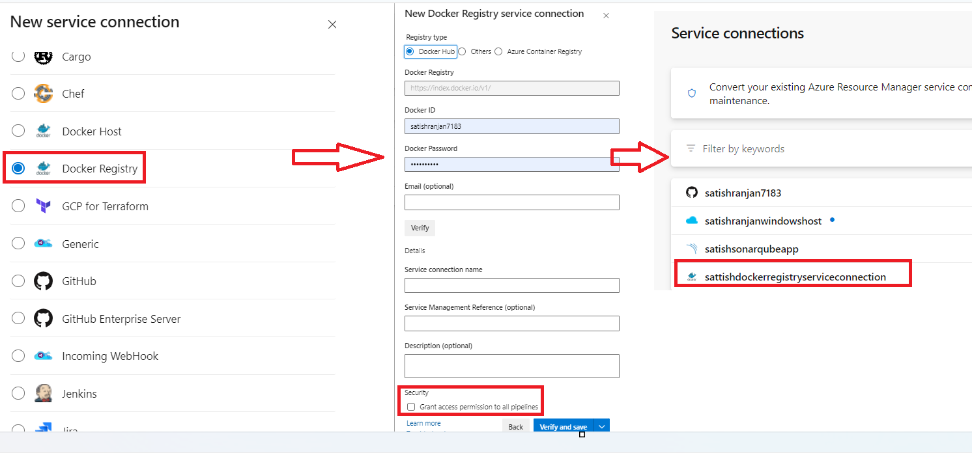

**Step 1:** To create docker Service connection

Login to dev.azure.com, then go to service connection - > New Service Connection -> select docker registry -> Next

In Registry Type -> Select docker hub -> Put docker id and password -> and then click to verify to test.

Put any service connection name and click on to grant permission of all pipeline.

**Step2:** Now go to repo and import docker source file in our azure repo

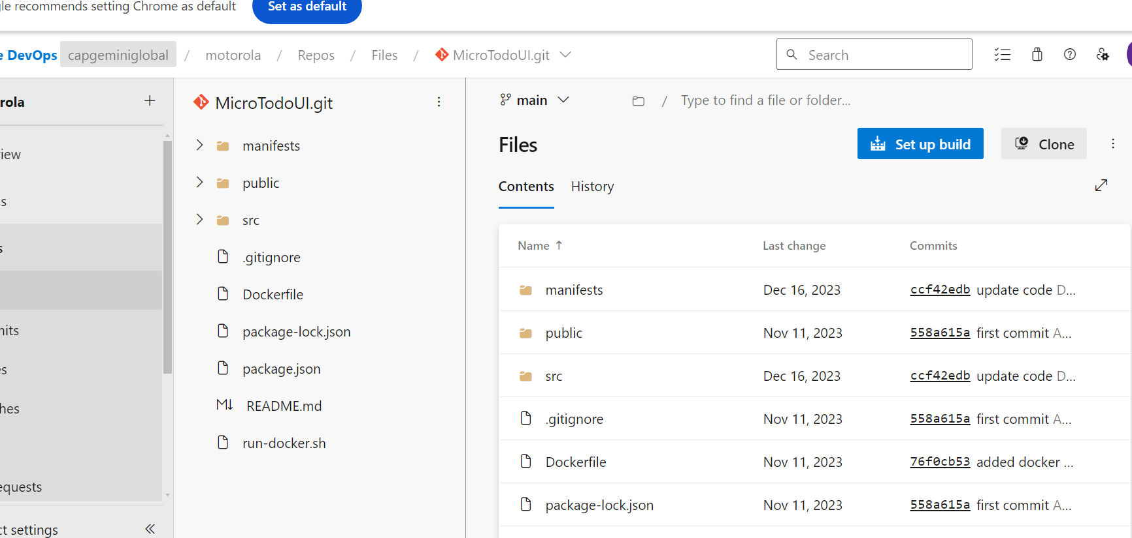

**Step3**: Now need to create one pipeline for building image and push this image to docker hub.

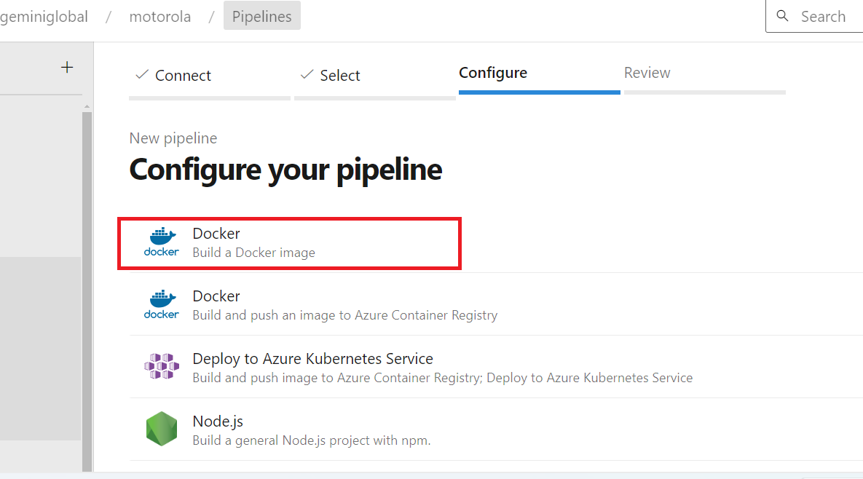

**Step4:** Code for pipeline.

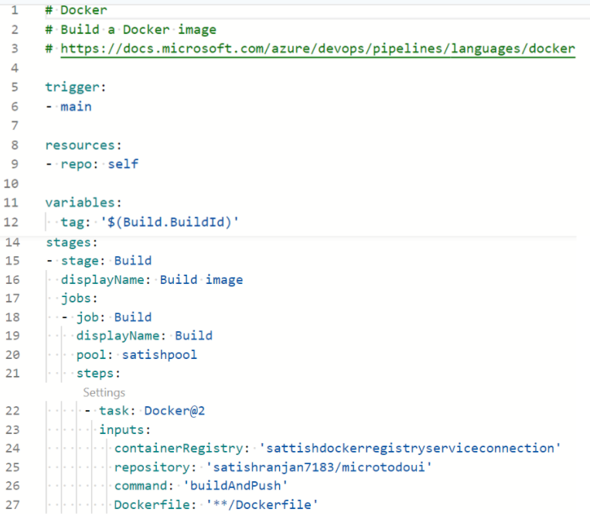

**Step5**: Now we can run pipeline and then we can check our image present on our docker hub registry.

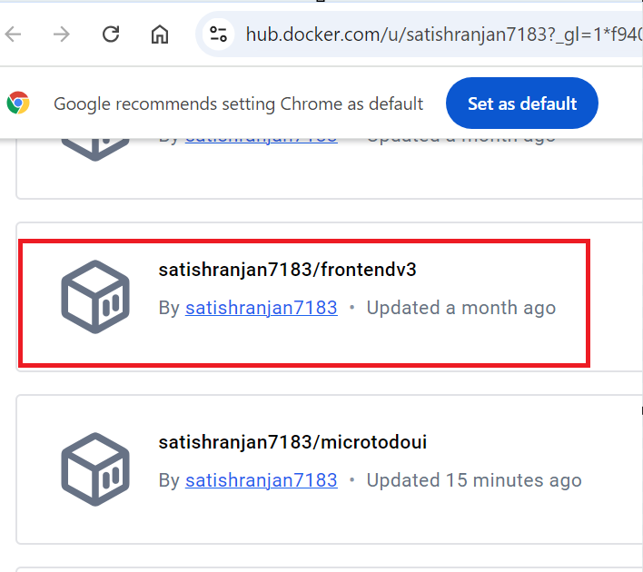

**Step6**: Now we build one container and expose it.

we can run this command from self hosted docker agent. Our container will expose on port no 8000.

Docker images

Docker run -d -p 8000:80 <imageid>

We can check 192.168.1.38:9000